**Software Integration**

**Data, Servers, Clients, Requests and Responses**

**Software** – API (Application Programing Interface)

**Servers** – Data

**Data** :- is the form of symbols – 1s and 0s, other digits, letters, special characters etc.

Can be: collected, measured, analysed, processed further : stored in databases (Database servers)

**Server:** a combination of hardware and software for storing, managing and processing large amounts of data

* Web Servers – Web pages
* Database servers – Database Queries
* FTP Servers – Files

The client Server Model

Client request a service from a Server (have access to some data)

Some software will provide the service

Server can be local server and it will be connected through cable.

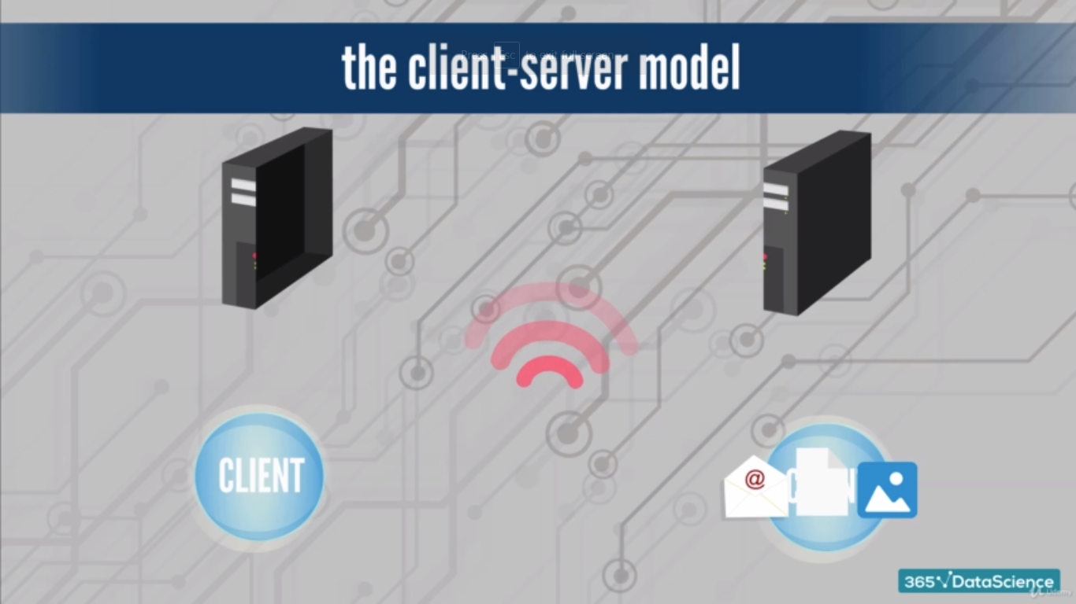

**Data Connectivity**: regards the ability to connect clients and server, securing the swift and voluminous transfer of information between them

* How can one connect information from multiple servers simultaneously?
* How is this data delivered to the clients?

By using APIs

**API’s (Application Programming Interface)**: a contract allowing software to share data with each other

= Let’s devices and software applications communicate in real time

**Interface:** using inputs, a device a capable of execute certain operations to produce output

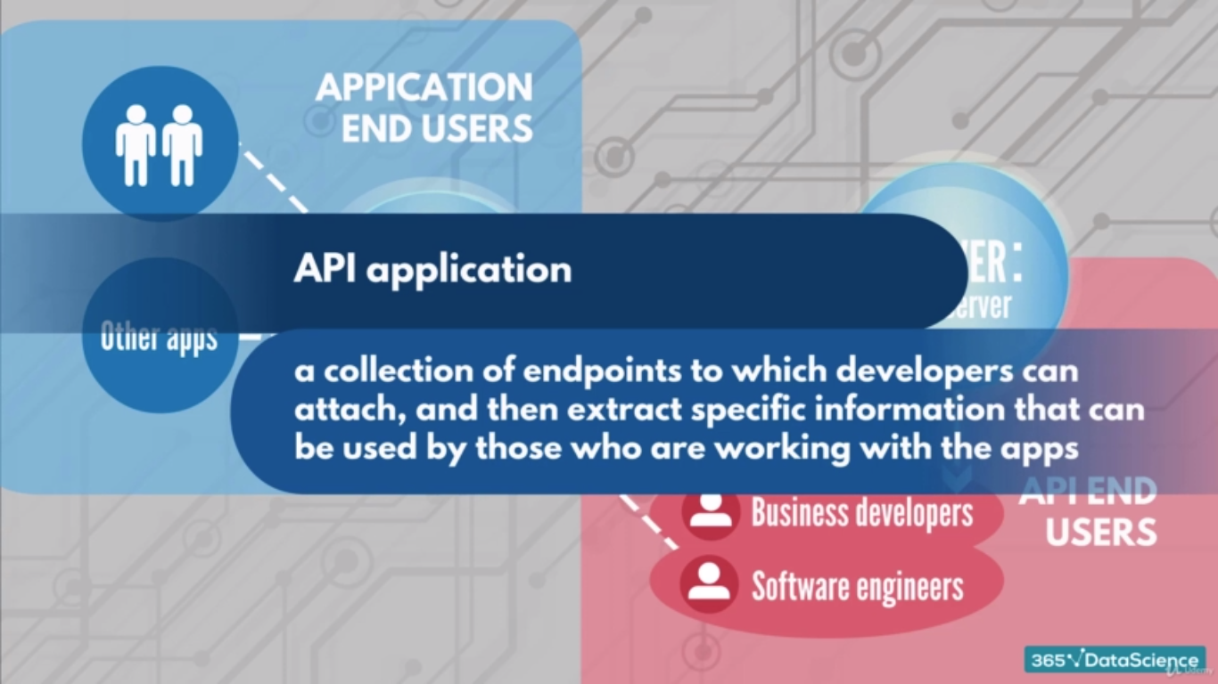

**Data asset**: data that is expected to have some value in the future : forms of data or software related to the processing of information

* Intellectual Property:
  + Patents
  + song
* databases
* websites
* code

**Application (app):** a program design to perform a specific set of operations for the end user, be it a person or another application.

* Web Browsers
* Video Editing Programs
* Database management software

**Programming:**

* Refers to the function the app performs
* Regards the process of converting inputs into outputs

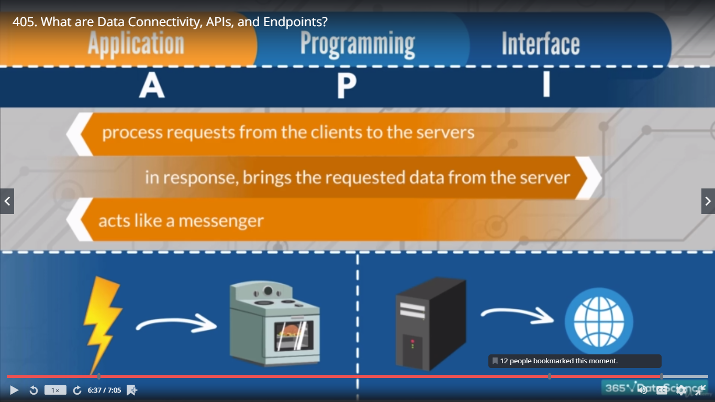

**Limitations:**

* An API does require maintenance
* Security: APIs must act as a filter (vs. malicious programmers and overloading & guarantee quality access)
* Private information:

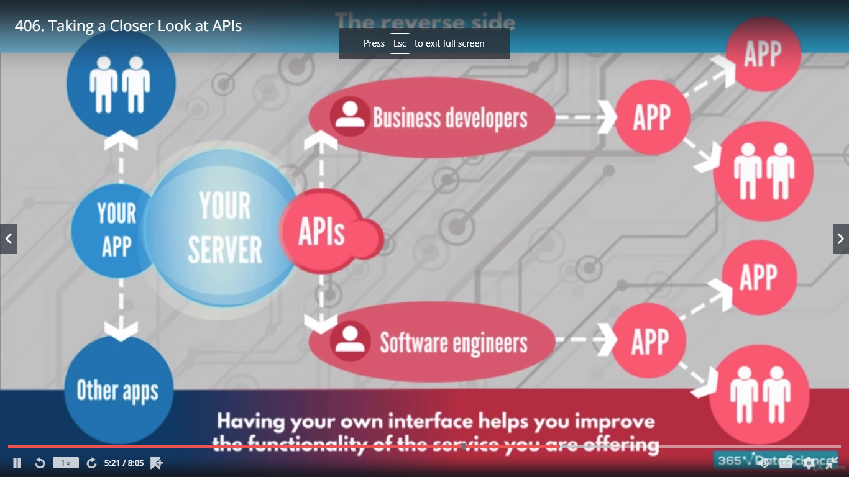

**Using APIs:**

* saves enormous amounts of your time
* provides access to numerous databases
* is very efficient when delivering precisely the information you need

**Software Integration**

* **Software:** can be written in any of the hundreds of programming languages out there
* Is it somehow possible to send data from a program written in one language to a program written in another?
* Different pieces of software (software products) communicate through text files
* APIs act like a messenger between the end user of the apps and the servers
* APIs act like a gateway to the server (or a bridge between the two pieces of software)
* Interfaces help you establish connections

Text file formats:

* .xml, .csv,
* .json: JavaScript – object – notation
  + Just an ordinary text file
  + All modern programming languages can read, export to, or work with JSON
  + Developers find it a lot easier to translate, or to parse, a JSON string

**Integration:**

* A system, or an architecture, composed of a few different software product, various programming languages, or other pieces of software which can communicate with each other via APIs, or a common API
* A situation where multiple software products can be set up to work as one tool
* Mixture of first two

**Driver**

* a software driver can “drive” a certain software product within another one
* It is a piece of software. Its function is to mediate between two products
* TabPy’s server allows you to execute Python code remotely and on the fly thanks to a build-in-driver
* Each component of the SQL-Python-Tableau system can send information that is afterwards processed towards the other components
* Tableau’s build in drivers:
  + May leave the user completely unaware of their existence
  + Allow tableau to centralize the advantage of using SQL relations and Python computations

